

PRESCHOOL PARENT PROGRAM GUIDE

2024-2025


The Sandusky City Schools Preschool Program Parent Guide is used with the Elementary School Student Handbook.
The Parent Program Guide and Student Handbook together identify rules and regulations of the Sandusky City School Schools Preschool Program.

Approved July 16, 2024 by the Sandusky City Schools Board of Education

This page intentionally left blank.

TABLE OF CONTENTS
Preschool Program Letter 3
Purpose 4
Philosophy 4
Licensing 4
Key Principles 4
Preschool Related Services 4
Preschool Curriculum 5
Program Days and Hours of Operation 5
Transportation 5
Program Requirements 6
Ohio Early Learning and Development Standards and State Testing 6
Transition Plan 6
Non-Discrimination Statement 7
Parent Complaints 7
Tuition 8
Enrollment/Withdrawal Procedures 8
Missing Children 8
Program Calendar and Weather Closings 8
Attendance, Arrival, and Departure Procedures 9
Daily Program Schedule 10
Breakfast/Lunch/Snack Guidelines 11
Clothing 11
Birthday Celebrations 12
Toys, Books, Games, Blankets, or Other Possessions Brought from Home 12
Field Trips 12
Safety of Children 12
Parent Participation Policy 13
Discipline Policy 14
Release of Names, Pictures, and Achievements 15
Recording – Video/Audio 15
FERPA – Confidentiality Policy 15
Toilet Training 16
Management of Communicable Disease 16
Signs and Symptoms of Communicable Disease 16
Removal of Sick Child 17
Medications at School 18
Medicaid School Program Billing Statement 18
Healthcheck Services 19
Registration Forms 19
Physicals/Immunizations 20
Conferences 20
Change of Address 20
Child Abuse 20
Telephoning the Classroom 20
Emergencies and Accidents 20
Preschool Supply List/Miscellaneous 21
Forms 22


Sandusky Early Learning Academy
Early Childhood Education Programs
2314 Hancock St., Sandusky, Ohio 44870-4994
419-984-1210

Preschool Program

Dear Families:

Welcome to the Sandusky City Schools Preschool!

Our program targets the individual learning needs of all children. We also provide interventions to students who may be “at risk” for delayed growth in their early learning.

Our curriculum is both language-based and play-based. It is aligned with the district’s elementary curriculum. Sandusky teachers and support staff assist your child in developing cognitive, pre-academic, social and emotional, and both fine and gross motor skills. This is taught through a variety of engaging, hands-on learning activities/lessons.

Families are a vital part of a child’s development. We highly encourage you to work with our teachers and support staff in order to create a strong, supportive learning network for your child. We encourage you to visit your child’s classroom and communicate often with teachers and support staff. Within this handbook you will find information about our preschool and daily program procedures.
We are looking forward to working with you and your child throughout the coming year. Sincerely,
Preschool Team

Sandusky Early Learning Academy
2314 Hancock Street
Sandusky OH 44870-4994
419-984-1210

419-984-1212 Preschool Absence Line

PURPOSE
The purpose of the Sandusky City Schools Preschool is to provide a comfortable and enriching environment that respects each child’s qualities and nurtures development towards his or her full potential.

PHILOSOPHY
Childhood is a series of firsts – first experiences, first friendships, first challenges, first hopes, first dreams, first surprises, and first successes – to be celebrated by everyone. We believe parents and families are their child’s first and primary teachers who work with other educators as partners. Children need time to be children, to explore their environment with curiosity and discovery. Play is children’s work. Without play there is no childhood. The Sandusky City Schools Preschool programs are designed to foster personal, social, emotional, and intellectual growth in a developmentally appropriate, play-based learning environment. The curriculum is based upon teacher observations and knowledge of children’s special interests. Developmental progress that emphasizes learning as a process of interacting with materials and people are an integral part of our program. Our curriculum is aligned to the Early Learning and Development Content Standards adopted by the State Board of Education. The state standards are addressed through the teacher’s lesson plans. Children’s learning activities in the classroom will most often be characterized as play, real and relevant to their lives. The primary goals for children will emphasize socialization, physical and language development. Children will be involved in a variety of free-choice, center-based, and group learning opportunities throughout the day.

LICENSING
The Sandusky City Schools Preschool Program is licensed by the Ohio Department of Education. The licensing component requires compliance to inspections by the health, building, and fire departments, as well as licensing evaluators from the Ohio Department of Education. Our license is posted in each classroom, as well as a copy of the most recent compliance report. A copy of the most recent or previous reports will be made available upon request.

KEY PRINCIPLES
- The children are members of a community that celebrates the uniqueness of each child’s race, culture, religion, gender, age, and ability. Differing levels of ability, learning styles, and development are expected, appreciated, and used to design appropriate learning activities which are motivated by the child’s interests and individual growth.
- Play encourages children to learn by active exploration through hands on discovery. Preschool
experiences match the child’s developing abilities while also challenging the child’s developing interests and understanding.
- A blending of children, families, and staff to create a nurturing environment for those we serve is a major focus throughout the program. The contributions of all are valued as we work together to give children time to fully celebrate childhood.

PRESCHOOL RELATED SERVICES
The Sandusky City Schools Preschool Program provides a variety of support services to enhance the education of young children. Additional services are provided for your children by: school psychologist, speech-language pathologist, occupational therapist, physical therapist, guidance counselor, and nurse, when appropriate. Additional services, such as health screenings or assessments, may be available when needed per the student’s program.
When support services are a part of your child’s educational program, they are provided following team collaboration and include suggestions for classroom activities and adaptations.

PRESCHOOL CURRICULUM
Our teachers are trained early childhood educators. The curriculum is developed around the needs of our students. Creative Curriculum (our adopted curriculum) is approved by the Ohio Department of Education and follows the state standards. If you would like a copy of the Ohio Early Learning and Development Content Standards, please ask your child’s teacher. In our supportive classrooms, Creative Curriculum provides children opportunities to learn and practice newly acquired skills in an environment where children are safe and valued. The curriculum also offers challenges just beyond the level of their present mastery.
We encourage hands-on experiences, as children learn by doing. The curriculum is focused around four areas of development and ten areas of interest. The four major areas of development are:

Social/Emotional – This is the process in which children learn the values and behaviors accepted by society.

Physical Development – Physical development is as important as academic development and considers fine motor and gross motor skills. This includes moving large muscles and coordinating small muscles in the hands and wrists. It supports the child’s academic development, general health, self-esteem, stress management and social development.

Cognitive Development – Children learn to problem solve by purposefully acquiring information, resources, and materials. By gathering and making sense of the information, they learn to think logically. This is accomplished by comparing, contrasting, sorting, classifying, counting, measuring, and recognizing patterns. By pretending they will also learn to represent and think symbolically.

Language Development – Language development is the process of communicating through verbal and nonverbal means. This includes listening, speaking, reading, and writing. Children will begin to enlarge their vocabulary, express themselves, understand speech from others, and participate in conversations. They will be exposed to written language that facilitates understanding the purpose of print and how it works while gaining knowledge of the alphabet letters, writing, and words.

PROGRAM DAYS AND HOURS OF OPERATION
The Sandusky City Schools Preschool at Sandusky Early Learning Academy (SELA), offers a developmental curriculum for children ages 3 to 5 years. A child will attend 4 days per week; Tuesday, Wednesday, Thursday, Friday.

The hours of the center-based program during the school year are as follows: AM Sessions: 7:50 a.m. to 11:00 a.m.
- Drop off no earlier than 7:35 a.m. - 7:45 a.m. south entrance
- Pick up no later than 11:00 a.m. south entrance

PM Sessions: 12:00 p.m. to 3:10 p.m.
- Drop off no earlier than 11:45 a.m. – 11:55 a.m. south entrance
- Pick up no later than 3:10 p.m. south entrance

Sandusky City Schools Preschool follows the Sandusky City Schools Calendar for the school year, i.e. all holidays, vacations, etc.

TRANSPORTATION
Transportation is available for students identified with disabilities and those qualified in the Sandusky City Schools Preschool ECE Program. Busing is not available for students enrolled as “typically developing students.” Parents of these students must make their own transportation arrangements. Bus Transportation
- For questions regarding busing, please call the Transportation Department directly at 419-984-1330.

PROGRAM REQUIREMENTS
The program is guided by written policies of the Sandusky City Schools Board of Education that are consistent with the Rules for the Education of Preschool Children with Disabilities (Ohio Revised Code Chapter 3301-31), Operating Standards for Ohio’s Schools Serving Children with Disabilities (Chapter 3301-51), and Rules for Preschool Programs (Ohio Administrative Code 3301-37). Copies of the Rules and Standards are available in the building for your review. If you have any questions regarding these regulations, contact the Ohio Department of Education (ODE), Division of Early Childhood Education at 614-466-0224.

OHIO EARLY LEARNING AND DEVELOPMENT STANDARDS AND STATE TESTING
The preschool curriculum aligns with the Early Learning and Development Standards. The Early Learning and Development Standards identify essential concepts and skills for young children. These standards serve as a guide for expectations as children complete their preschool experiences.
The preschool program participates in Ohio mandated assessments of all enrolled preschoolers and assesses all enrolled children using formal and informal methods on an ongoing basis to inform instruction.

A pre-reading assessment tests for early literacy skills. The test is administered in the fall and spring. Results are shared with parents and reported to the Ohio Department of Education. Children will also participate in the PELI (Acadience Early Literacy) benchmarking and progress monitoring.

In the spring and fall, screenings are administered to detect indicators that a child might have a developmental problem that needs to be further investigated. The Developmental Indicators for the Assessment of Learning- Third Ed (DIAL-4) is used to screen for developmental delays. Administered to children ages 3 to 6 years, it includes direct observation and tasks presented to the child.

Children with disabilities are also provided a rating using the Early Childhood Outcomes Summary Form (ECOSF). This assessment summary is used to give a rating for three federal student outcomes relating to positive social-emotional skills, acquisition and use of knowledge and skills, and use of appropriate behaviors to meet their needs. These ratings, when reviewed based upon child entry into and exit from preschool, provide a way to determine student outcomes after their preschool experience.

Ohio’s Early Learning Assessment is a tool for teachers of preschool age children to learn about the current level of each child’s skills, knowledge and behaviors in the areas of Social Foundations, Language and Literacy, Mathematics, Science, Social Studies, Physical Well-Being and Motor Development, and Fine Arts. This assessment will require teachers to observe children during the natural course of the child’s day. As required by the Ohio Department of Education (ODE), the program ensures that all children receive a vision and hearing screening, as well as comprehensive developmental screening that is valid and reliable, within 60 business days of entry into the program and annually thereafter. Necessary referrals, which may include classroom monitoring and follow-up screening and/or referral to determine special education eligibility, are completed within 90 days of identification of need and the results are formally communicated with families. Results of these assessments and screenings are shared and discussed with parents/guardians.

TRANSITION PLAN
Sandusky City Schools believes communication and knowledge are crucial components in successful transitions for children, parents, and staff. These transitions include, but are not limited to, preschool to kindergarten/school-age programs, home, and out-of-home care programs to community programs, within programs to new classrooms, and birth-2 years of age programs to preschool.

A child’s team, including the parents, meets to complete a transition planning form when a planned transition (to another classroom, site, program) is coming to detail the activities that will be completed in order to assist and support the child and family in the next environment as well as the party responsible for completion of the transition. The completed form is signed, dated by all applicable team members present, and copies are made for all team members.

Activities provided to support children and their parents will include, at a minimum; open house visits prior to the start of school; children spending time in another classroom in the same program prior to a formal transition; written information regarding registration and screening dates; choosing a cubby or name symbol to decorate and identify their space; classroom activities such as books and videos relating to starting preschool or school; and opportunities for receiving preschool or kindergarten teachers to visit toddler or preschool classrooms. Each child transitioning from one program to another shall have a written transition plan in place which will involve input from parents, teachers, and other members of a child’s team as appropriate. Responsibilities for transition activities will be delineated on the written plan.

Information about registration and screening will also be shared with the community through the use of media such as press releases and flyers. Sending and receiving staff shall communicate to determine the student information that shall be shared after receipt of any required parental consent.

The program ensures that children who are age-eligible are enrolled in kindergarten upon leaving the early childhood program unless another placement has been determined based on parental choice.

NON-DISCRIMINATION STATEMENT
It is the policy of the Sandusky City Schools that educational activities, employment practices, programs, and services are offered without regard to race, national origin, gender, sexual orientation, religion, handicap, age, place of residence, or social or economic background.

PARENT COMPLAINTS
It is the intent of the Sandusky City Schools Preschool Program to provide all parents and guardians with an avenue for discussing and resolving any concerns they have in regard to the care being provided by the center. Resolving parent questions and complaints in a timely manner is a priority for our preschool staff. Please let us know when you have an issue. To efficiently resolve complaints, parents should take the following steps:
- First, discuss the concern or complaint with the preschool teacher.
- It is suggested that in order to facilitate the conversation, an appointment should be scheduled.
- You should prepare a written list of pertinent discussion points prior to the appointment.
- A written summary of the discussion and agreements are also encouraged.
- After the teacher has addressed the issue, the parent/guardian should consider the issue resolved.
- If the teacher was unable to address, or if the parent or guardian is dissatisfied with the response or outcome, he/she should then discuss the issue with the Preschool Program Coordinator.
- A meeting will be scheduled, and the parent/guardian should be prepared to discuss what has transpired to date.
- The Preschool Program Coordinator will research the issue and respond to the parent in a follow-up meeting, or at the initial meeting if no research is needed.
- If you have not received a satisfactory response from the Preschool Program Coordinator, schedule a meeting with the Principal at 419-984-1210.
- Continuing concerns can be brought to the Superintendent of Sandusky City Schools for consideration.
- Ohio Department of Education offers a Preschool Ombudsman service for all preschool issues. The Ombudsman can be reached at 614-466-0224.

TUITION
The Sandusky City Schools Preschool Program does not charge tuition.

ENROLLMENT/WITHDRAWAL PROCEDURES
Enrollment includes students from the Sandusky City Schools who meet the eligibility requirements for a preschooler with disabilities. Eligibility is determined based on the Rules for the Education of Preschool Children with Disabilities (Chapter 3301.31).
Enrollment for children not meeting the eligibility criteria is available to residents of Sandusky City Schools. Parents must complete the on-line registration application. Complete each step, sign as prompted, then save and submit. Your form will be time, date stamped. If information is missing or incomplete, your registration form will not be accepted until completed. In the event that the program has reached its capacity, your child’s name will be placed on a waiting list until such time there is an opening in the program. All applicants will be restricted to children living in the Sandusky City Schools’ district boundary.

Students need to be age 3 or 4 by October 1st. Any exceptions must be approved by the Principal.

The On-line Enrollment must be complete before your child may begin attending the preschool. The Child’s Medical Statement must be completed within 30 days of enrollment and completed by a physician, physician’s assistant, clinical nurse specialist, or certified nurse. A new physical form is required for returning students every 13 months from the date of the most recent examination.
If you need to withdraw your student, please call the SELA Administrative Assistant at: 419-984-1210 to officially withdraw your child from Sandusky City Schools Preschool Program.
If you need to withdraw your IEP student, please contact the Student Services Director at 419-984-1024 to withdraw your child from the Sandusky City Schools Preschool Program. If transferring to another district, please provide the new district’s contact information so that records can be transferred.

MISSING CHILDREN
The following information will be required for any new student enrolling in the Sandusky City Schools Preschool program:
- Academic records/report card from the school most recently attended
- Immunization records
- Birth Certificate
- Name, address, and telephone number of the school most recently attended
- Address and telephone number of the new residence within the service district
- Certified copy of a court-ordered decree allocating parental rights and responsibility for the care of the child and identifying a residential parent and legal custodian of the child (if appropriate)
Any child determined to be missing as designated by the Missing Children’s Act will be reported immediately to the Missing Children’s Clearinghouse and the proper law enforcement agency.

PROGRAM CALENDAR AND WEATHER CLOSINGS
When inclement weather forces the DELAY or CLOSING of our program, an announcement will identify Sandusky City Schools. The following radio and television stations broadcast the delay or closing: WLEC Sandusky 1450 AM
WCZP Sandusky 102.7 FM WTOL CHANNEL 11 Toledo
WTVG CHANNEL 13 Toledo
Continued…

In the event that Sandusky City Schools close, dismiss early, or experience a delay in opening time due to weather or other emergencies, you will receive a “One Call.” This is an automated notification system and a primary phone number will be used as obtained from the annual Emergency Medical Authorization Form. On our school website you also have the ability to add additional phone numbers for notification. If you miss a phone call, the district’s primary phone number, 419-626-6940, will appear on your caller ID.

If Sandusky City Schools announces a two-hour delay, the AM session of preschool will be CLOSED. The PM session of preschool will remain open unless Sandusky City Schools announce they are closing.
At times, it may become necessary to close the school during the day due to weather conditions, such as snow, fog, flooding, etc. We will attempt to contact all parents/guardians in this situation. It is not always possible to get in touch with everyone, so we are asking that you please listen to the above stations for information regarding times of closing.

ATTENDANCE, ARRIVAL AND DEPARTURE PROCEDURES
Regular attendance is important for all aspects of a child’s development. Attending regularly allows the child to build relationships with peers and staff. It provides multiple opportunities for the child to learn the routines of the classroom and the environment of the school. Most importantly, it provides the foundation that contributes to future academic growth.
Parents are required to notify the school their child attends when a child is absent. Please call the school each day of your child’s absence. (Preferably before the beginning of your child’s class.) Please be ready to provide the following information:
- Child’s name
- Child’s teacher
- Brief explanation of child’s illness

Follow-up with a written excuse upon child’s return. A doctor’s excuse may be requested in the event of a long-term absence. If your child comes to school on a bus, please notify the Transportation office at 419- 984-1330, if they will be absent.

If your child accumulates more than 5 days (15 hours) of unexcused absences, they may be dismissed from the program.

If we do not hear from you, we will be calling you to inquire about your child’s absence. Please note that we are required to follow the Missing Child Act of 1985.

Parents who transport their children to the morning session of Sandusky City Schools Preschool are asked to drop off their children at the designated drop-off area no earlier than 7:35 a.m. At the end of the session, parents may pick up their child at the designated area no later than 11:00 a.m. For the afternoon session, parents are asked to drop off the children no earlier than 12:00 a.m. Afternoon students should be picked up no later than 3:10 p.m. It is important that each child be picked up promptly at dismissal time. It can be very upsetting to a child for a parent to be late!

Please avoid late arrivals and pick-ups so that staff may attend to their additional responsibilities.
If your child arrives or departs at other than the regularly scheduled time, the adult accompanying the child must report and sign in/out at the school office.

If your child will not be attending on a regularly scheduled day, please notify The Sandusky Early Learning Academy by calling 419-984-1210. When your child is absent, please send a note on the day of his/her return.

A CHILD WILL NOT BE RELEASED TO AN UNAUTHORIZED PERSON! A note written and
signed by the parent/guardian must be sent to the Preschool Teacher if someone other than the parent/guardian is picking up the child.
Parents/Guardians are asked annually to provide written approval of having their name, phone number, and child’s name on any group/program roster. This roster is not furnished to any person other than parents/guardians.

DAILY PROGRAM SCHEDULE
Sandusky City Schools Preschool Program is based on the open learning center concept. The daily schedule is setup to allow ample time for the children to participate in the various learning centers, be a part of a group of children working together and explore the outdoors.

Learning Center Time
Children are free to choose a learning center activity such as role-playing in the dramatic play center, experimenting in the science and nature center, working on puzzles in the manipulative center, painting in the creative art center, building in the block center, or experimenting with movement in the gross motor center.
The teacher/assistant use this time to work with individual children on skill development or with small groups of children on a particular activity. Children are offered new challenges, asked thought-provoking questions, and encouraged to try new things.

Small Group Time
Children join their teacher for story time which includes movement and/or musical activities that promote social skill development, enjoyment, and fine and large motor development. The teacher also uses this time to present activities that are developmentally appropriate for the children in the group. These activities revolve around themes for the week and will include math concepts, language activities, learning about ourselves, etc.

Outdoor Play Time
Outdoor activity is planned daily so children can develop large muscle skills, learn about outdoor environments, and express themselves freely and loudly. Preschool staff monitors weather conditions at the outdoor playground. Please dress your child appropriately for the weather conditions. Outdoor play is restricted if wind chill is too low or if the play area is wet. If you feel your child is too ill to participate in the outdoor playtime then possibly he/she should not be in attendance. A student restricted from outdoor play will require a physician’s note.

BREAKFAST, LUNCH AND SNACK GUIDELINES
An important part of the children’s day is breakfast and lunch, not only for their eating enjoyment, but also because nutrition affects their mental functioning and physical well-being.
The daily breakfast or lunch is provided by the program. Breakfast and lunch are selected in consideration of the children's nutritional needs and dental health.

No child is forced to prepare or consume any meal. If your child has special dietary needs or food allergies, please notify us in writing.

Snack Guidelines
If a parent/guardian would like to donate a snack for their child’s class, please note the following guidelines on nutrition. According to our licensing rules issued by the Ohio Department of Education and the Ohio Revised Code, preschool snacks must have items representing at least two of the main food groups: meat/meat equivalent, bread/bread alternative, milk, and fruit/vegetable.
Some suggestions for a nutritious snack are:
- cream cheese or cheese cubes with crackers
- apples, celery, or bananas
- popcorn and orange slices or pineapple chunks or grapes (must be halved)
- carrot sticks, celery, cauliflower, broccoli, with dip
- other fruits
- fruit juices – 100% real fruit juice
- milk or milk alternative if requested on the Emergency Medical Form

Vitamin C - Vitamin C has several important functions in the body, such as helping to form bones and teeth and healthy skin and tissue. Vitamin C also plays a significant role in wound healing and maintaining strong blood vessels. Since our bodies do not make Vitamin C, we must eat foods, which provide us with it. It is a good idea to eat foods with Vitamin C every day. (*indicates a very good source)
Important food sources of Vitamin C:
asparagus | avocado | *broccoli | squash | *cauliflower
*cabbage, raw | *cantaloupe | *greens | mangos | *grapefruit/grapefruit juice
*green pepper | *strawberries | *pineapple | lima beans | *lemon/lemon juice
*brussel sprouts | *spinach | *raspberries | peas | *tomato/tomato juice
*potatoes | *papaya | turnips | Vitamin C fortified cereal | *orange/orange juice
Vitamin A - Vitamin A is important for normal growth, healthy skin and tissues, and proper bone development. Vitamin A is also important for good vision, especially in dim light or darkness. Since our bodies store Vitamin A, including a good source of this vitamin at least every other day will insure an adequate intake. (*indicates a very good source)
Important food sources of Vitamin A:
*kidney beans | eggs | Cheese | *enriched corn grits | fortified butter/margarine
*apricots | ice cream | *liver | *winter squash | Vitamin A fortified cereal
*broccoli | asparagus | *greens | *pumpkin | tomato/tomato juice
*cantaloupe | nectarines | *mangos | *spinach | cabbage
*carrots | papayas | prunes | *sweet potato | fortified milk

CLOTHING
When selecting your child's clothing, please keep in mind that many of the daily classroom activities involve work with paints, clay, sand, water, food, etc. Staff is not responsible for clothing that becomes stained or extremely soiled.
Staff members encourage children to help themselves whenever they can. This gives them a sense of accomplishment and control over their environment. It would be helpful if parents would select coats, pants, sweaters, hook and loop Velcro© closure shoes, boots, etc. that the children can manipulate themselves. For children who are working on toilet training, easy clothing is a must. Clothes that can easily be pulled off/on such as sweatpants are ideal for toilet training purposes. Clothes with tight fasteners such as jeans and overalls or other clothing items that are hard to manipulate such as belts are not suitable for children learning to use the toilet. Please buy mittens for your children as they are easier for little hands than gloves.

ALL CLOTHING MUST BE LABELED! Many times children do not recognize their own belongings.

By the first day of school, it will be necessary for parents to send an extra pair of underpants, socks, pants, shirt, slippers, or shoes for your child. If your child's clothing becomes extremely soiled or wet, we will change the child into the extra set of clothing and the wet or soiled clothes will be sent home in a bag. Please wash and return the extra set of clothes to the class as soon as possible.

Diapers – If your child is not yet toilet trained, please send diapers and wet wipes with his/her name marked on the bag and container. (Only pull-ups with tabs will be accepted.)D
Shoes – Please do not send your child with backless shoes.

BIRTHDAY CELEBRATIONS
Every child’s birthday is a big event at the preschool. Even birthdays that fall in the summer or during breaks will be celebrated. You are welcome to send a nutritious snack for a birthday treat, see page 11 for Snack Guidelines. Please notify the teacher in advance if you plan to do this.
If your religious beliefs do not allow birthday and holiday celebrations please inform your child’s teacher of the appropriate placement of the child during these activities.

TOYS, BOOKS, GAMES, BLANKETS, OR OTHER POSSESSIONS BROUGHT FROM HOME
If your child is having difficulty making the transition from home to the class, it may be helpful to bring a favorite toy/item from home. It is very easy to lose a child’s toy/item in a group setting. So once your child has adjusted, he/she will be encouraged to leave the item in his/her locker/book bag. Items should be marked with the child’s name
On special occasions, toys from home will be encouraged in order to promote a certain theme. At these times, a note will be sent home beforehand. Please do not send weapon toys to the preschool.

FIELD TRIPS
Field trips that enrich the preschool curriculum may be organized occasionally. Parents are welcome to join in the outing. Parents must be volunteer approved, submit an “Application for Volunteer Service,” form 053, and have a non-conviction statement on file, and request permission in advance for each field trip.

SAFETY OF CHILDREN
We are very concerned about the safety of the children attending Sandusky City Schools Preschool program. The following safety procedures are in effect at all times:
- No child is left alone or unsupervised at any time.
- A telephone is located in the classroom and is available for use in the event of an emergency.
- Fire drills are held in conjunction with the elementary schedule and the school staff and children practice threatening weather drills. A record of these drills is kept in the school's office.
- Fire emergency and weather alert plans, including diagrams showing evacuation routes, are posted in the classrooms.
- The use of spray aerosols is prohibited when children are in attendance.
- If a child has a serious accident or becomes injured while at the preschool, a staff member will
administer first aid while another school staff member contacts the local rescue squad and the child’s parents. Remaining staff members will care for the other children. If the parents cannot be reached, only the people listed as emergency contacts on the child's Emergency Medical Authorization form will be notified. A staff member will accompany the child to the hospital, if necessary.

- In the event of a non-serious accident (superficial cuts, scrapes, bruises), staff will administer first aid if necessary.
- When an accident or injury occurs, staff will complete the injury report form provided by the office. A copy of this form will be given to the parent and a copy will remain on file at the school for at least one year. The program shall maintain a log of injury reports.
- In accordance with Section 2151.421 of the Ohio Revised Code, all Sandusky City Schools staff are required to report any suspicions of child Abuse or Neglect to the Erie County Department of Human Services. All Sandusky City staff members are required to complete an approved course in recognizing signs of child abuse and neglect.
- All staff members are aware of the safety rules for both indoor and outdoor activities and the class and playground areas are surveyed continuously for possible safety hazards.
- All preschool staff members are trained in first aid, infant and child CPR, and recognition of communicable diseases. A first aid kit is always on site.
- Preschool staff members shall have a medical statement as required upon employment/assignment to preschool and every three (3) years thereafter.
- Preschool staff members, non-teaching staff, and volunteers will follow all applicable licensure and rule requirements.
- Preschool teachers and other preschool staff, as appropriate, shall be aware of pertinent child background information to assure safety and awareness of special needs.

PARENT PARTICIPATION POLICY
According to the Ohio Department of Education (ODE) Preschool Licensing Rules, parents/guardians of children enrolled in the class have unlimited access to the class during class hours for the purposes of evaluating the care provided by staff, observing the program in operation, or evaluating the premises. Please report to the school office, sign in and receive a visitor’s badge before going to your child’s classroom/play area.
While parents can observe at any time, they are not permitted to hinder the learning process.

Parents are also welcome to participate in the daily program as often as they wish. Please notify your child's teacher prior to the day you want to volunteer. Volunteers are often asked to read stories, assist in the art center, or play games with the children. Any parent wishing to volunteer must submit an “Application for Volunteer Service,” form 053, and have a BCI/FBI check and non-conviction statement on file. BCI/FBI checks should be filed with the school office. Payment of BCI and FBI background checks will be paid at the volunteer’s expense.

If you need assistance with a problem or have a complaint related to the class or its program, you are welcome to take your concerns to your child's teacher, Preschool Program Coordinator, Sandusky Early Learning Academy Principal or the Director of Special Education. Staff members are always open to suggestions for improving the program.

A calendar is sent home every month. The calendar highlights themes, snacks, special events, and important dates. Information helpful to parents will be sent home periodically. If you would like to contribute to the newsletter, please let us know!

Parent meetings, information regarding local/regional workshops, book fairs, parties, and other special events may also be provided for parents. Parents are encouraged to make suggestions for meetings/workshops, daily schedule, curricular topics, and activities. Parents are also encouraged to share any special appropriate talents (play an instrument, art skills, etc.) with the students.

A formal progress report on each child is sent home at least twice per school year. Parent-teacher conferences are scheduled in the fall and spring. Informal and formal parent-teacher conferences are held as needed. Parents may request a conference with any staff member at any time.

Play dates may also be scheduled by your child’s teacher. The students, their parents (or responsible adult if parents are not available), and staff meet at a community site (example – farm, bowling, pizza, etc.) for learning and social activities.

DISCIPLINE POLICY
The goal of discipline is to help each child build his/her own self-control, and ultimately, direct his/her own behavior. Staff members recognize the important role self-esteem plays in the process and strive to enhance each child’s feelings of self-worth. A well-planned and supervised classroom will prevent many behavior problems. Clear and responsible rules are established for each child’s safety and rights. These rules are discussed and reviewed periodically with all children and shared with parents.
Sandusky City Schools is required to Create Caring Communities by using Positive Behavior Interventions and Supports (PBIS). PBIS uses individualized positive strategies to reinforce desired behaviors, diminish reoccurrences of challenging behaviors and teach appropriate behavior to students. Preschool staff members will follow behavioral interventions to improve school climate and culture to achieve improved academic and social outcomes and increase learning for all students. A student may be removed for the remainder of the school day under ORC 3313.66(C) if the student’s presence poses a continuing danger to others or property or is an ongoing threat of disrupting the academic process in a classroom or elsewhere on school premises.

Problem-solving techniques are encouraged in the classroom during which time the staff often acts as facilitators, helping young children express feelings and generate solutions as well as redirecting a child’s interest/frustrations to another activity. These problem-solving techniques are also used if a preschool child exhibits any act of bullying. Additional guidance will be provided through separating the child from problem situations, talking with the child about the situation, and praising the child for appropriate behavior.

As needed, a behavior plan will be developed with parental input if traditional classroom management and early childhood discipline techniques are not adequate to meet a child’s needs.
Physical restraints are used only if there are safety concerns or if included in a formal behavior plan.
Based on ODE Preschool Licensing Rules and Sandusky City Schools policies, staff members follow these discipline guidelines:
- Preschool staff member(s) in charge of a child(ren) are responsible for discipline. Policies are in effect for all staff in all preschool areas, including playground, field trips, or other school-sponsored activities.
- All preschool staff members shall be informed of and receive a copy of the Sandusky City Schools discipline policies upon employment and annually in the handbook.
The preschool staff’s actual methods of discipline shall apply to all persons on the premises and shall be restricted as follows:
- There shall be no cruel, corporal punishment, any unusual punishments, or any punishments such as, but not limited to, punching, pinching, shaking, spanking, or biting.
- No discipline shall be delegated to any other child.

- No physical restraints shall be used to confine a child by any means other than holding for a short period of time, such as in a protective hug, so the child may regain control.
- No child shall be placed in a locked room or confined in an enclosed area such as a closet, a box, or a small cubicle.
- No child shall be subjected to profane language, threats, derogatory remarks about himself/herself or his/her family, or other Discipline shall not be imposed on a child for failure to eat, sleep or for toileting accidents.
- Techniques of discipline shall not humiliate, shame, or frighten a child.
- Discipline shall not include withholding food, rest, or toilet use.
- Separation, when used as discipline shall be brief in duration and appropriate to the child’s age and developmental ability, and the child shall be within sight and hearing of a preschool staff member in a safe, lighted, and well ventilated space.
- Staff shall not abuse or neglect children and shall protect children from abuse and neglect while in attendance in the preschool program.
- Sandusky City Schools preschool staff members receive on-going training in Crisis Prevention Institute’s Non-Violent Crisis Intervention© to ensure the care, welfare, safety, and security of all individuals on the premises.

RELEASE OF NAMES, PICTURES, AND ACHIEVEMENTS
On occasion, student names, pictures, and achievements may be published in newspapers, programs, school websites, and other forms of publications. Permission forms permitting the release of this information must be returned to the appropriate staff member.
When you are taking pictures or video of your child at school, be aware that not all parents/guardians have granted permission for the release of their child’s image. Please be sensitive to the rights and expectation of privacy of your child’s classmates when displaying the images on social networking sites and other public venues.

RECORDING – VIDEO/AUDIO
In order to protect the privacy rights of students and staff, electronic video and/or audio recordings of Sandusky City Schools activities is not permitted unless permission has been granted by the parent. Said permission will be in the form of a signed authorized statement as included in your child’s enrollment packet. Upon signed permission from a parent, Sandusky City Schools has permission to publish in print, electronic, or video format the likeness or image of your child. This may be published in formats such as activity programs, yearbooks, newspapers, or other school-related publications, websites, and video announcements.

FERPA – CONFIDENTIALITY POLICY
The Family Educational Rights and Privacy Act (FERPA) affords parents and students who are 18 years of age or older certain rights with respect to the student’s educational records. These rights are:
- The right to inspect and review the student’s education records within 45 days after the day the Sandusky City Schools receives a request for access.

- The right to request the amendment of the student’s education records that the parent or eligible student believes is inaccurate, misleading, or otherwise in violation of the student’s privacy rights under FERPA.

- The right to provide written consent before the school discloses personally identifiable information from the student’s education records, except to the extent that FERPA authorizes disclosure without consent.
  - Sandusky City Schools may disclose appropriately designated “directory information” without consent, unless the parent has submitted a written refusal by the end of the second full week of school, “Family Educational Rights and Privacy Act (FERPA)” form 020.
  - Directory information is defined by Sandusky City Schools as the student’s name, address, telephone number, date and place of birth, and dates of attendance.

- The right to file a complaint with the U.S. Department of Education concerning alleged failures by the Sandusky City Schools to comply with the requirements of FERPA. The name and address of
the Office that administers FERPA are:
Family Policy Compliance Office
U. S. Department of Education
400 Maryland Avenue SW Washington, DC 20202

TOILET TRAINING
Students who are not on IEPs are expected to be potty trained prior to the start of preschool. For students on an IEP, we will work cooperatively with the parent to accomplish this as consistency between home and school is critical for a child’s success. Staff members prefer that you keep your “trainee” in pull-ups to assist in accomplishing this task.

MANAGEMENT OF COMMUNICABLE DISEASE
The preschool staff is trained and certified in First Aid and in recognizing the signs and symptoms of communicable diseases. The "Child Day Care Center Communicable Disease Chart" is posted to help staff in recognizing illnesses. Parents are welcome to view this chart at any time.
Staff is very conscientious about the importance of hand washing and disinfecting procedures to prevent the spread of communicable diseases. The children are also reminded to wash their hands on a regular basis.

As children arrive, a staff member greets and observes each child for possible signs and symptoms of illness. If your child is exhibiting any of the symptoms listed, you will be asked to take the child home.

SIGNS AND SYMPTOMS OF COMMUNICABLE DISEASE
The following precautions shall be taken for children suspected of having a communicable disease:
- The program shall immediately notify the parent or guardian of the child's condition when a child has been observed with signs or symptoms of illness.
- A child with any of the following signs or symptoms of illness shall be immediately isolated and discharged to his parent or guardian:
  - Diarrhea (three or more abnormally loose stools within a twenty-four-hour period).
  - Severe coughing, causing the child to become red or blue in the face or to make a whooping sound.
  - Difficult or rapid breathing.
  - Yellowish skin or eyes.
  - Redness of the eye or eyelid, thick and purulent (pus) eye discharge, matted eyelashes, burning, itching or eye pain.
  - Temperature of one hundred degrees Fahrenheit taken by the auxiliary method when in combination with other signs of illness.
  - Untreated infected skin patch(es).
  - Unusually dark urine and/or grey or white stool.

  - Stiff neck with an elevated temperature.
  - Evidence of untreated lice, scabies, or other parasitic infestation. Upon occasion, students may be found to have head lice. Because of this condition, students must be excluded from school until corrective action is taken by the home. Your child will be readmitted to school after having head lice if she/he is nit-free as determined after an examination by the school nurse.
There will no exceptions to this procedure, see form 077, “Confirmation of Notice for Treatment of Head Lice,” located in the office and on the website at www.scs-k12.net.
  - Sore throat or difficulty swallowing.
  - Vomiting more than one time or when accompanied by any other sign or symptom of illness.
- A child with any of the following signs or symptoms of illness shall be immediately isolated from other children. Decisions regarding whether the child should be discharged immediately or at some other time during the day shall be determined by the school nurse and the parent or guardian. The child, while isolated at the program, shall be carefully watched for symptoms listed in paragraph (B)(2) of this rule as well as the following:
  - Unusual spots or rashes.
  - Elevated temperature.
- Programs shall follow the Ohio department of health's posted "communicable disease chart" for appropriate management of suspected illnesses.
- A child isolated due to suspected communicable disease shall be:
  - Cared for in a room or portion of a room not being used in the preschool program;
  - Within sight and hearing of an adult at all times. No child shall ever be left alone or Unsupervised.
  - Made comfortable and provided with a cot/mat or crib for infants. All linens and blankets used by the ill child shall be laundered before being used by another child. After use, the cots shall be disinfected with an appropriate germicidal agent, or, if soiled with blood, feces, vomit, or other body fluids, the cots shall be cleaned with soap and water and then disinfected with an appropriate germicidal agent.
  - Observed carefully for worsening condition.
  - Discharged to parent, guardian, or person designated by the parent or guardian as soon as practical.

REMOVAL OF SICK CHILD
If your child becomes ill while at school and exhibits any of the symptoms listed in the previous section, he/she will be cared for by a staff member in an area not being used by other children. You will be contacted immediately to come and pick up your child. If you cannot be reached, only the people listed as emergency contacts on your child's Emergency Medical Authorization form will be notified and asked to come to pick up your child. Your child will not be readmitted until symptoms are no longer present. In some cases of illness, a written note from your child's physician may be required.
Children must be free from diarrhea and fever for 24 hours before they will be readmitted to school.

A child with minor cold symptoms or a child in the final stages of recovery from an illness may attend if the child has seen a physician and has been diagnosed as non-contagious and/or is on medication. The child shall be carefully observed for signs and symptoms of a worsening condition. Should any of the symptoms listed occur, you will be notified immediately and be asked to pick up your child.
In the event that your child is exposed to another with a communicable disease, you will be notified in writing that he/she has been exposed to a contagious disease and informed so that you are aware of the symptoms.

The preschool staff will not administer any medication to children enrolled without the required “Prescriber’s Request for the Administration of Medication in School,” form 029, completed by your medical practitioner and on file at Sandusky Early Learning Academy, available at www.scs-k12.net or the office.

When a staff member is ill, the staff member will not be in attendance and a qualified substitute will be called to assume the responsibilities of that person.

MEDICATIONS AT SCHOOL
The administration of prescribed medication and/or medically prescribed treatments to a student during school hours will be permitted only when failure to do so would jeopardize the health of the student, or the student would not be able to attend school if the medication or treatment were not made available during school hours. Administration of over-the-counter medications will follow the same requirements and policies as prescription medication.
Before any medication or treatment may be administered to any student during school hours, a written authorization from the child’s physician and parent is required on the Sandusky City Schools, “Prescriber's Request for the Administration of Medication,” form 029. This form shall be kept on file in the student’s cumulative records. Only medication in its original prescription bottle, labeled with the date of prescription, student’s name, and exact dosage will be administered. Medication must be transported to the school by the parent/guardian or by giving it to the bus driver and delivered to the school’s main office or nurse’s office, where it will be stored in a locked area. Medication cannot be transported in the child’s book bag.

A parent/guardian wishing to discontinue the administration of medication at school must send a signed note to the office/nurse requesting the medication be stopped.

MEDICAID SCHOOL PROGRAM BILLING STATEMENT
The Sandusky City Schools participate in the Medicaid School Program (MSP) or a similar program. MSP is a federally funded reimbursement program. Sandusky City Schools uses a third party billing agency to submit MSP claims. This agency is in compliance with all federal privacy laws including the Health Insurance Portability Accountability Act (HIPAA) established in 1996.
The following is a list of personally identifiable information shared with the billing agency: student’s name, date of birth, social security number, district of residence, school of attendance, and professional services documentation. Professional services include screenings and assessments to determine eligibility for and the provision of services such as speech, occupational therapy, physical therapy, nursing, counseling, case management and psychological evaluations.

It is the parents’/guardians’ right to deny access to personally identifiable information or to revoke the use of it for purposes of MSP billing. Services will be provided regardless of disclosure of personally identifiable information. Copies of the billing agency’s privacy policy are available upon request. Please contact the Student Services Office for more information.

HEALTHCHEK SERVICES
Healthchek is Ohio’s Early and Periodic Screening, Diagnosis and Treatment (EPSDT) Program. It is a service package for babies, children, and young adults younger than age 21 who are enrolled on Ohio Medicaid. The purpose of Healthchek is to discover and treat health problems early. If a potential health problem is found, further diagnosis and treatment are covered by Medicaid. 20 Healthchek covers ten check- ups in the first two years of life and annual check-ups thereafter and offers a comprehensive physical examination that includes:

    - Medical history
    - Complete unclothed exam (with parent approval)
    - Developmental screening (to assess if child’s physical and mental abilities are age appropriate)
    - Vision screening
    - Dental screening
    - Hearing assessment
    - Immunization assessment (making sure child receives them on time)
    - Lead screening
    - Other services or screenings as needed
If your children are enrolled on Ohio Medicaid, Healthchek services are available to them. If you are younger than age 21 and are also enrolled, you can receive Healthchek services, too. If you still have questions about Healthchek, please call: Lenora Minor, Healthchek/PRS Coordinator, 419-668-8126, lenora.minor@jfs.ohio.gov or Carol Loose, Healthchek/PRS back-up, 419-668-8126, carol.loose@jfs.ohio.gov

REGISTRATION FORMS
All children attending Sandusky City Schools Preschool classes must be fully registered before they can attend Sandusky City Schools Preschool. The following forms must be completed annually:
Preschool Registration Form Additional Services Verification Form Residential Identification Form
Early Childhood Education Eligibility Screening Tool - due to information we are required to report, two consecutive proofs of income per income source is required. Any of the following are acceptable:
*W2 Form from the previous year
- Payroll Statement
- Tax form 1040 or 1040A from the previous year
- AFDC case number
- Food stamp case number Emergency Medical Authorization Form
Preschool Medical Evaluation (Physical) - All children are required by the State of Ohio to have a current medical statement on file. The medical statement must be completed by a physician and is good for one year from the date of the examination. All children must have a current medical statement in order to attend preschool.
Student Authorization Forms Combined
Preschool Parent Consent for Medical Health Screening Preschool Parent Roster Statement
Immunization Record - must be up-to-date and completed by a Physician or Health Department in order for the child to be fully registered and to attend the preschool
Copy of Birth Certificate
Legal Documents (if applicable) – includes: Name changes, adoption or custody papers. Legal documents must contain journal entry date stamp from the court and judges’ signatures to be valid. Parent Photo ID
Bus Transportation Eligibility

It is unlawful for Sandusky City Schools to discriminate in the enrollment of children upon the basis of race, color, religion sex, national origin or disability in violation of the Americans with Disabilities Act of 1990, 104 Stat.32.42 U.S.C. 12101 et seq.

PHYSICALS AND IMMUNIZATIONS
All children must have current and up-to-date physical and immunization records on file in order to attend preschool.
- Physicals/medical statements are valid for one (1) year from the date of the examination.
- New physicals must be turned into the preschool office within 13 months of the child’s current physical.
- You will be notified by the preschool office prior to the expiration of your child’s physical to allow sufficient time to obtain a new physical.
- All children must also have up-to-date immunizations on file in the preschool office.

CONFERENCES
Progress reports are sent home at least twice per year. Parent-teacher conferences are scheduled in the fall and spring and are held as needed. You may request a conference with the classroom teacher at any time.
Parents or guardians have access to the classroom during school hours for the purpose of talking with the teacher, evaluating the services provided by staff, observing the program in operation, or to evaluate the premises. We welcome your questions and visits to our program.

CHANCE OF ADDRESS, PHONE NUMBERS OR EMERGENCY NUMBERS
If you move during the year, it is important to send your new address immediately to your child’s teacher. This includes telephone number changes. It is important we have parent or guardian names and current emergency numbers. This form “Change of Address and/or Phone Number Notification,” form 093, is available on the district website at www.scs-k12.net the “Parents” tab at the top, and the “Forms” link below, and at any school office. If you go out of town, please notify the school and leave your babysitter or child care provider’s name. Please provide any additional emergency numbers or people to contact during your absence.

CHILD ABUSE
In accordance with Section 2151.421 of the Ohio Revised Code all preschool staff are required to report any suspicions of child abuse or neglect to the local public children’s services agency. Staff members have completed the required six-hour course prescribed by the Ohio Department of Human Services in recognizing signs of child abuse and neglect.

TELEPHONING THE CLASSROOM
If you need to call the classroom to speak with a staff member, please call before or after school. If you would like a telephone conference, please send a note and we will be happy to arrange a time. Please do not call the school during class time unless it is an emergency. Telephone interruptions take time away from the children’s important classroom activities.

EMERGENCIES AND ACCIDENTS
During the course of everyday play, minor accidents do occur. In the event of a minor accident involving a child, first aid will be administered immediately. Members of the Sandusky City Schools Preschool staff are certified to administer first aid, and periodically attend classes to keep this certification current. Should an accident occur or an emergency arise, parents will be notified immediately.
The required Emergency Contact Information Form Emergency Medical Authorization form 005/Preschool must contain the home and work numbers of both parents/guardian. If neither parent nor guardian can be reached, a staff member will contact one of the other adults listed as emergency contacts on the form. It is important that the emergency contact person is available and within a reasonable driving distance to pick- up your child when necessary.

Parents are required to complete an Emergency Transportation Authorization form Emergency Medical Authorization form 005/Preschool for every child in attendance at a Sandusky City Schools Preschool. If permission is granted to transport the child, Sandusky City Schools has the authority to contact emergency transportation for a child in the event of a serious accident. When minor accidents occur, parents are required to provide emergency transportation. Under no circumstances will a Sandusky City Schools Preschool staff member transport a child.

PRESCHOOL SUPPLY LIST
The following school supplies should be purchased, labeled with the student’s name, and sent to school within the first week. [Additional supplies may be requested and some supplies may need to be replenished throughout the school year.]

Preschool Supply Check List
1 complete change of clothing, including socks, to be kept at school for accidents/spills (Please label all items with your child's name)
1 Standard size backpack for student folders
1 Good quality crayons, box of 24 (Ex.: Crayola®)
2 Glue sticks
2 boxes of tissues (to share with class)
1 Low odor dry erase markers 4-color (Ex.: Expo®)
1 Good quality, washable, watercolor paints (Ex.: Crayola®)
Boys: 1 box zip top sandwich size bags (Ex: Ziploc®)
Girls: 1 box zip top gallon size storage bags (Ex: Ziploc®)
1 pack of wide washable markers
1 - 4 pack of Play-Doh®
1 bottle of white glue
1 - 1" Binder
Toileting supplies your child may need: diapers & wipes, extra training pants, etc.

MISCELLANEOUS

Things to Bring
Each child should bring a book bag clearly marked with his or her name to school each day. Please contact your child’s teacher for an additional list of supplies required for school. Children should not bring toys, books, or other items from home unless they are requested by the teacher. Guns, light sabers, swords, or weapons of any type are not allowed at preschool.

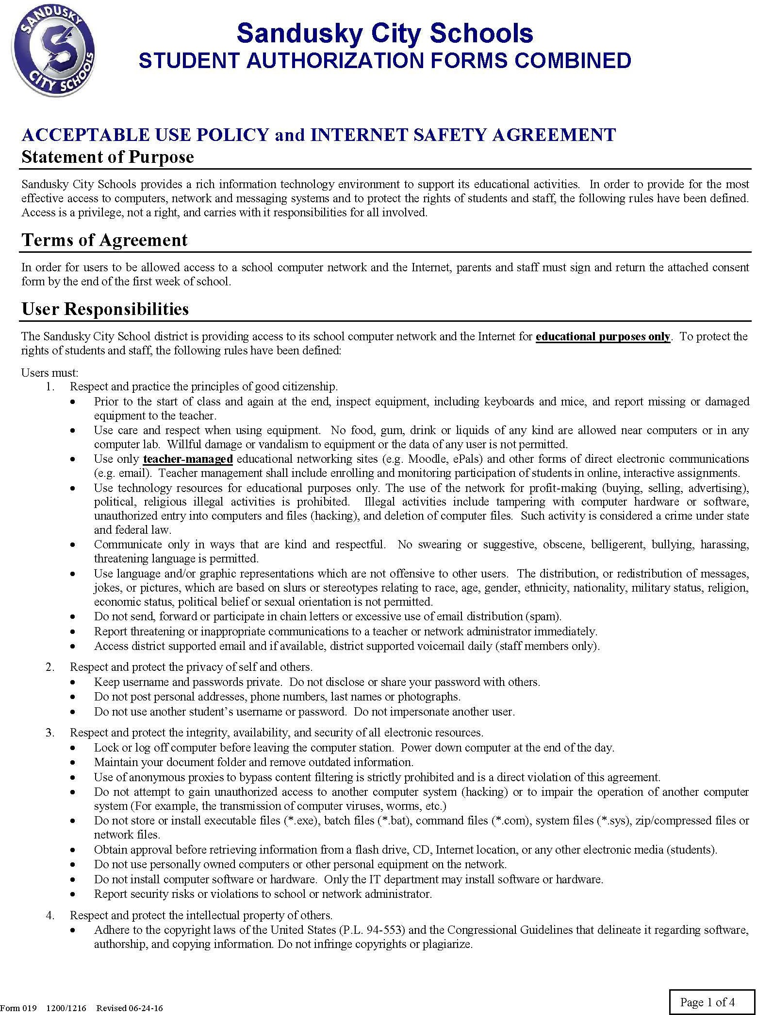

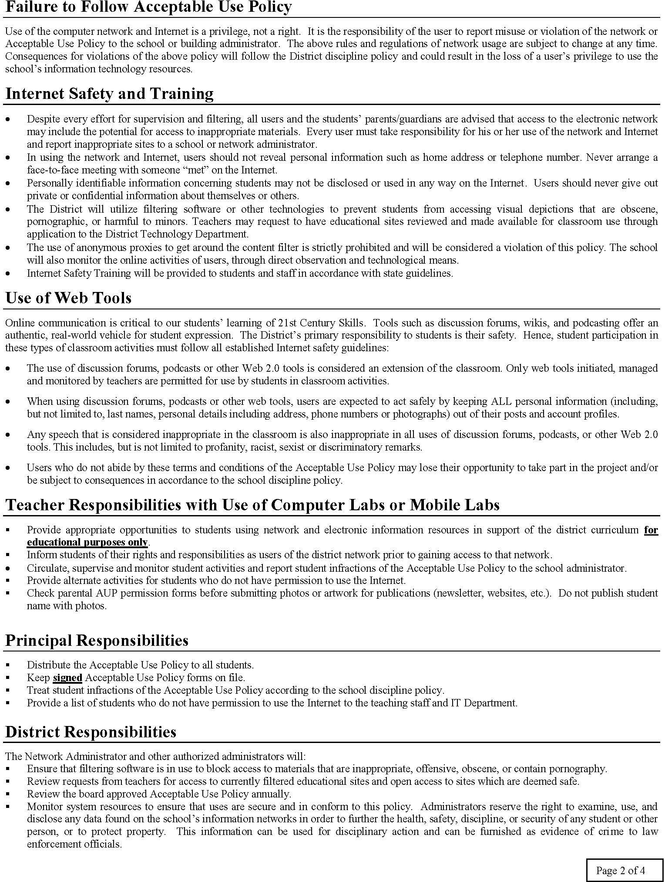

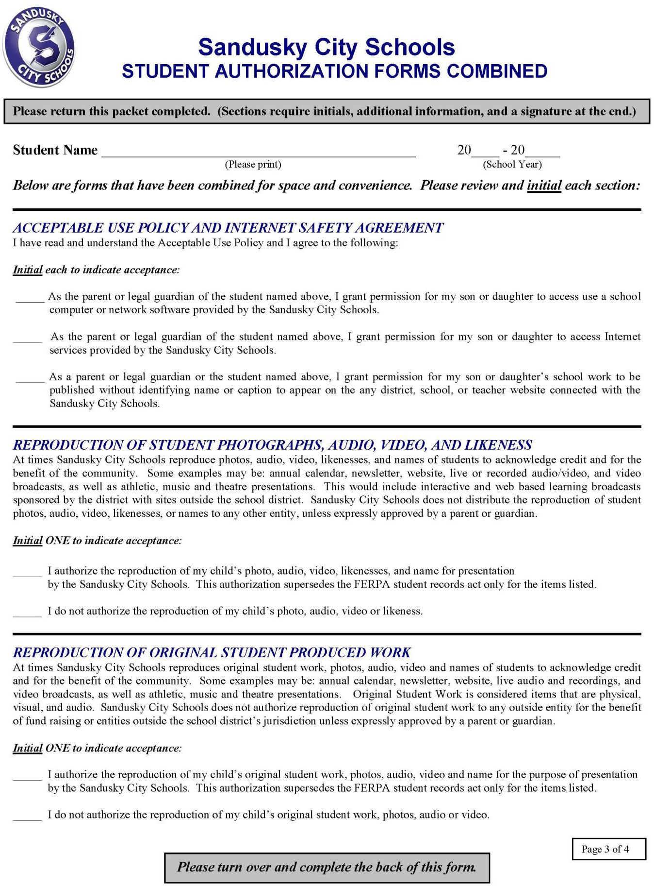

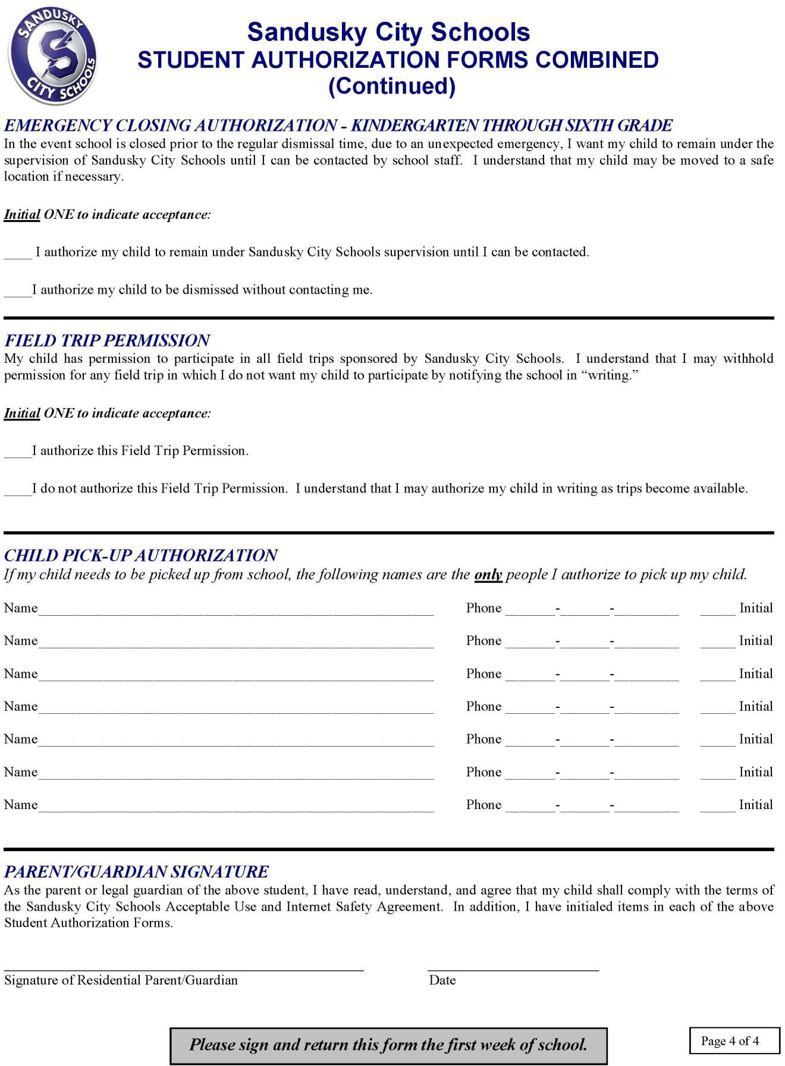

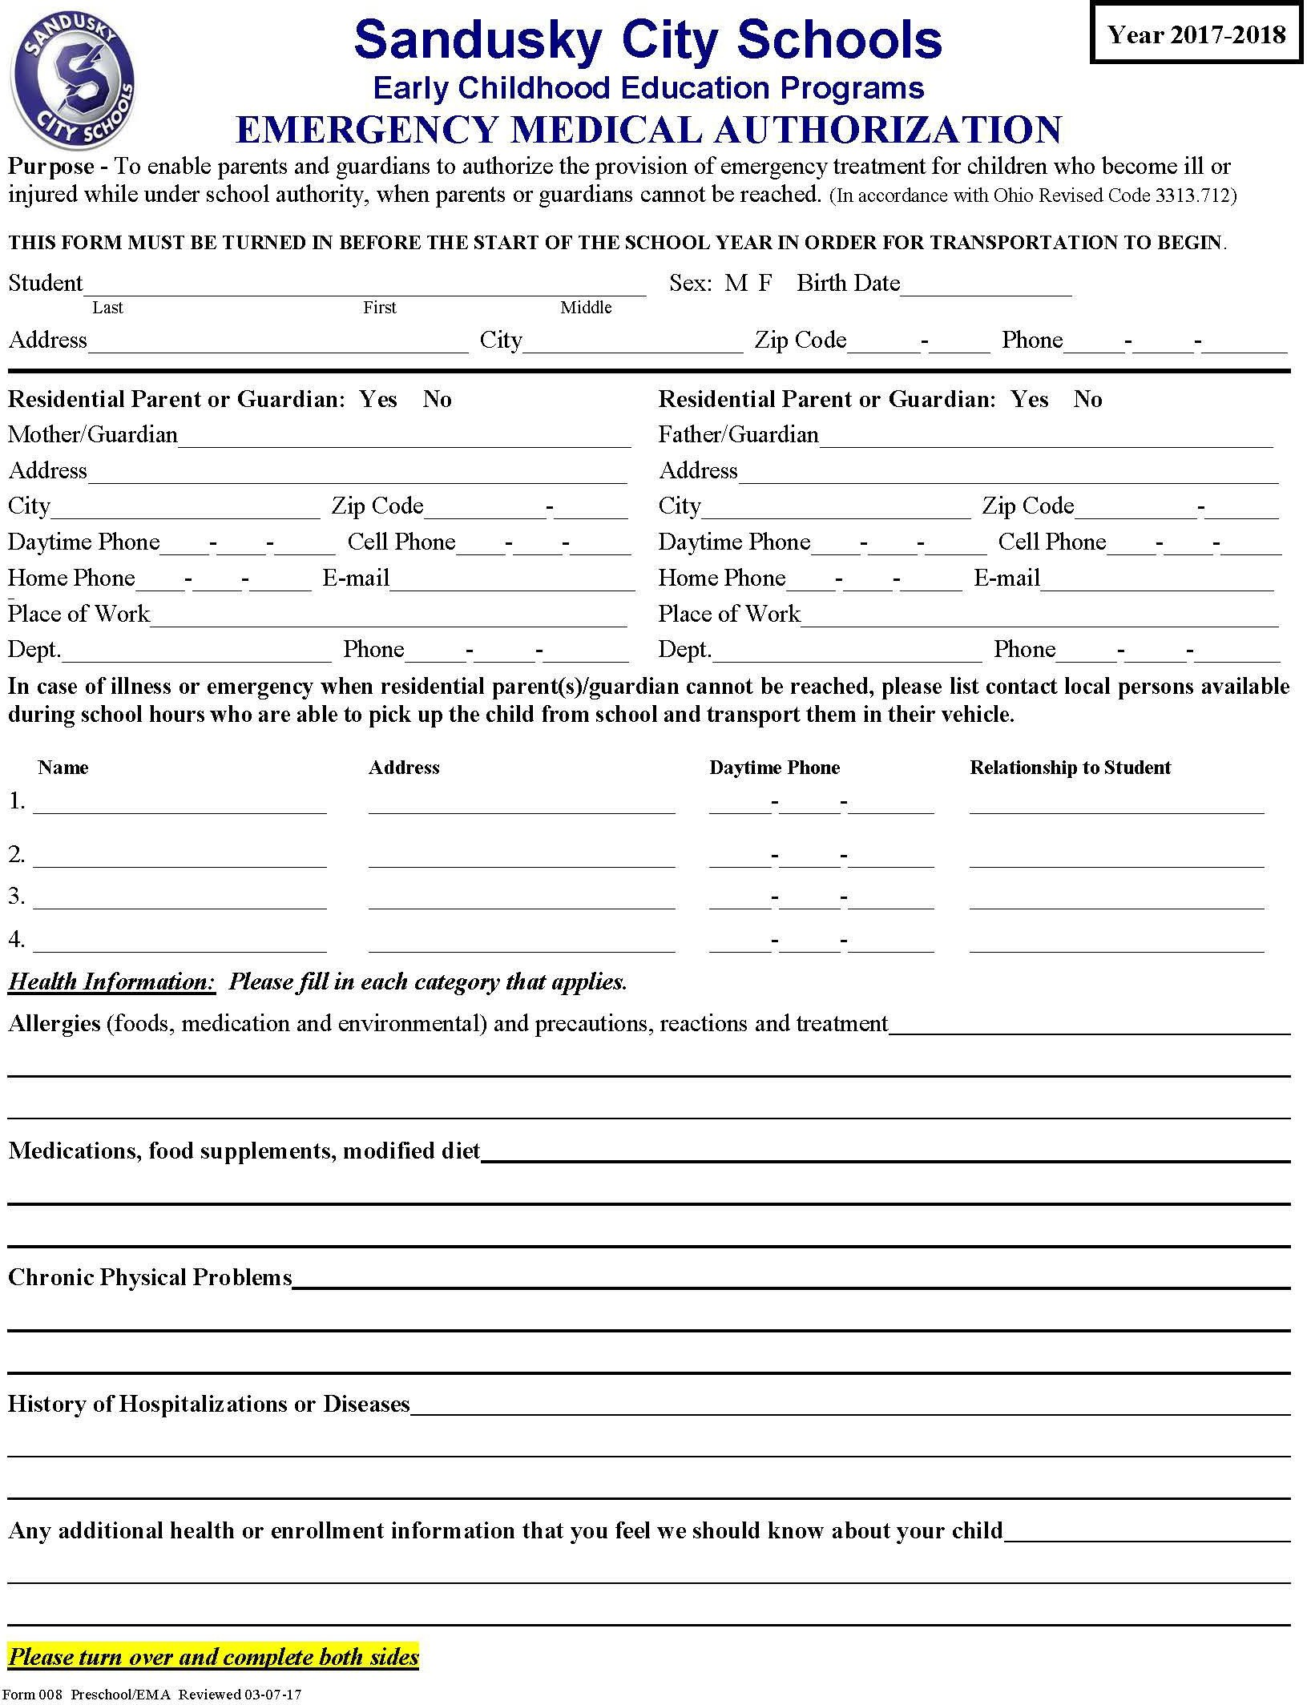

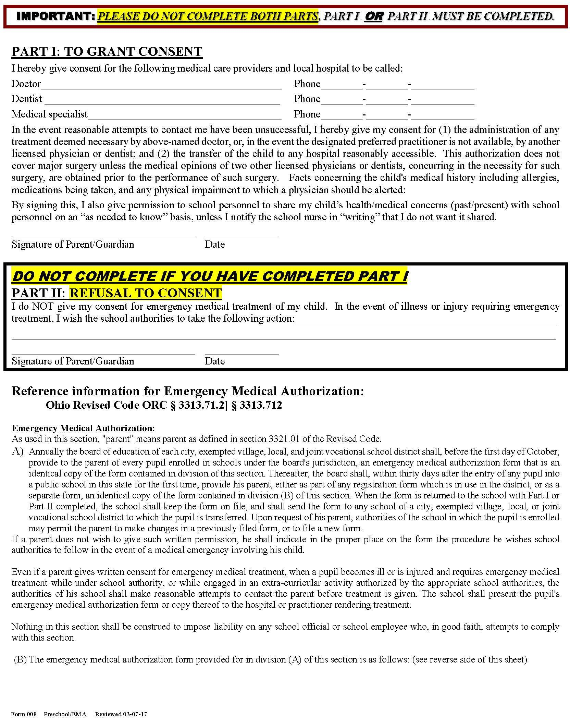

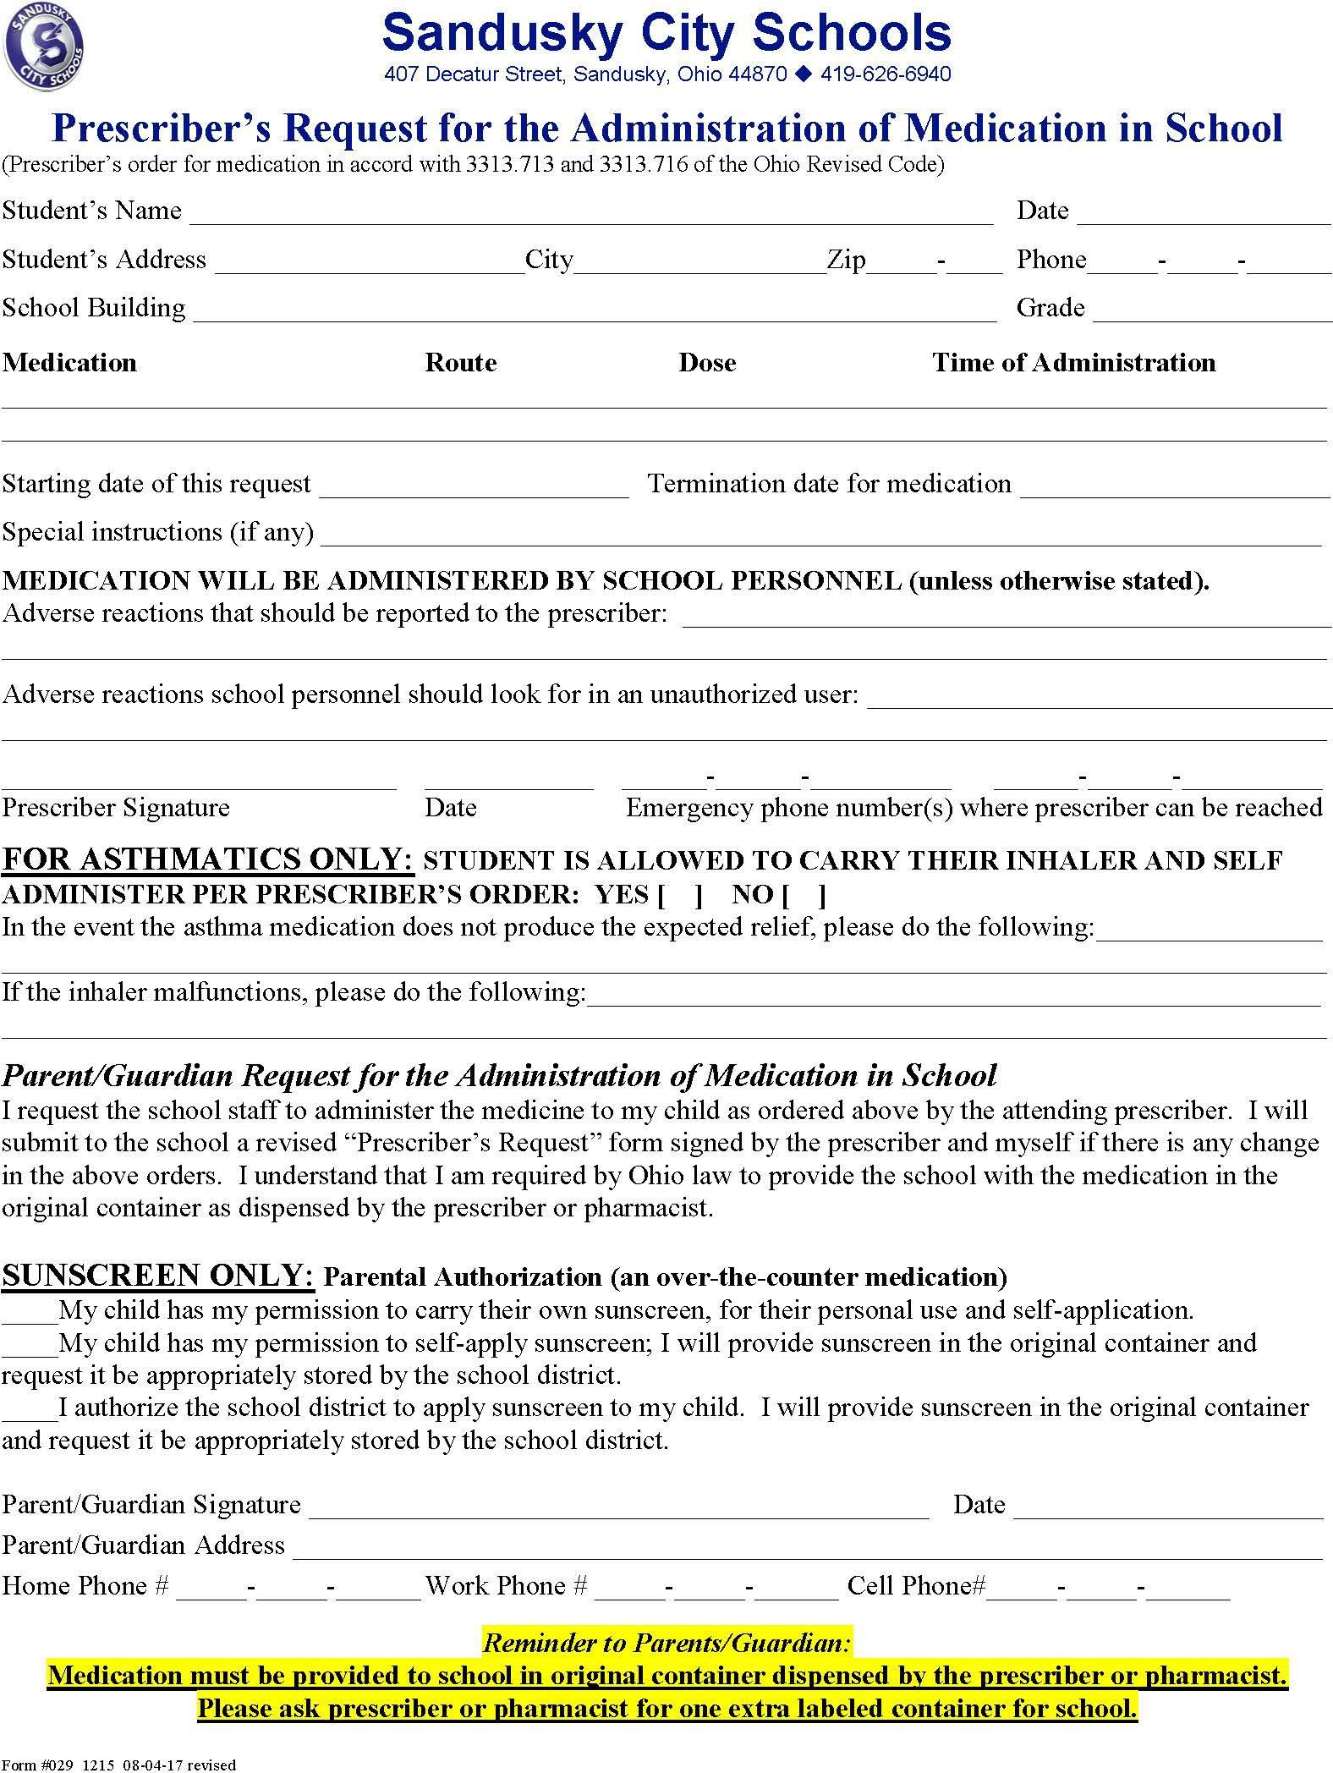

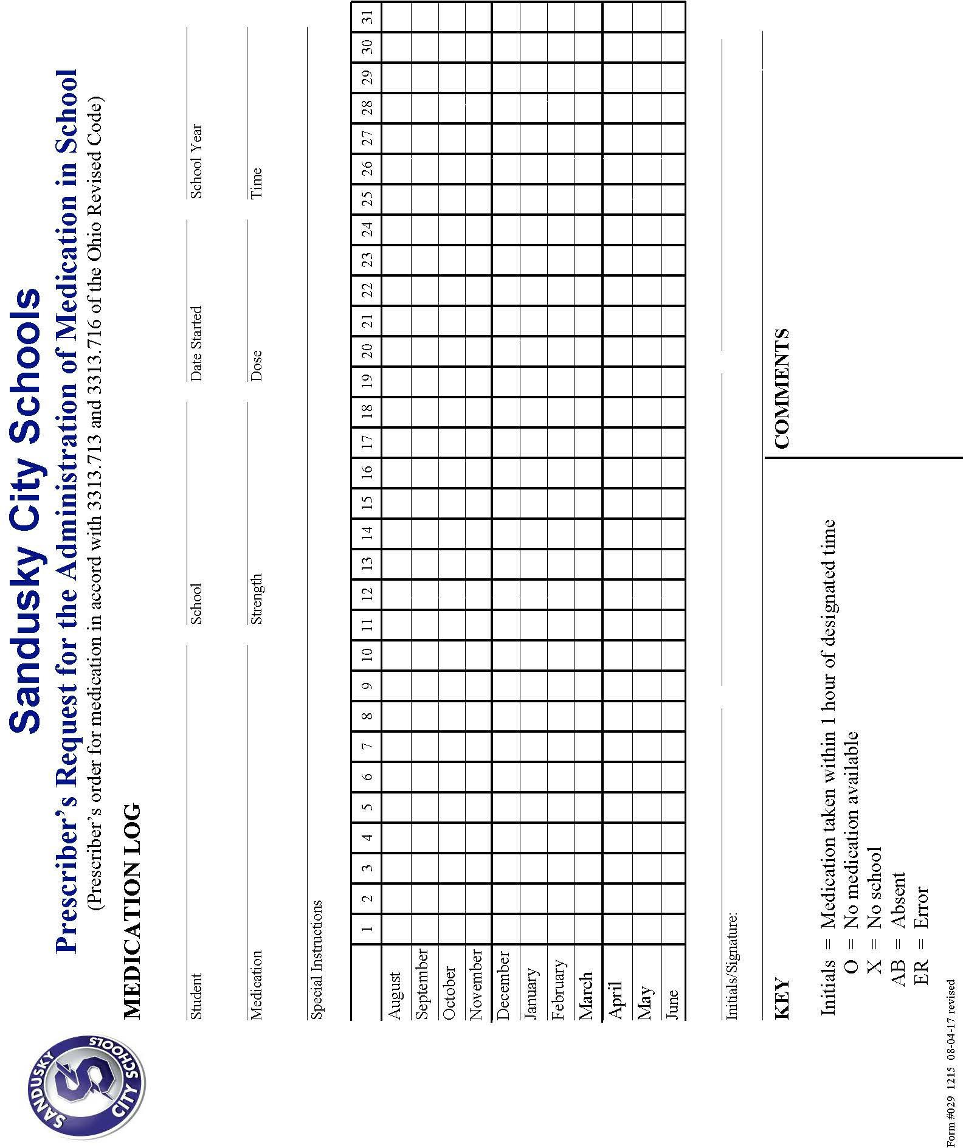


SANDUSKY CITY SCHOOLS
407 Decatur Street• Sandusky, Ohio 44870 • 419-626-6940

Office Use: Date of Application _ Position(s) Applying for. Athletic Volunteer
Academic Volunteer
APPLICATION FOR VOLUNTEER SERVICE
The Sandusky City Schools are equal opportunity employers dedicated to a policy of non-discrimination in relation to race, color, national origin, sex/gender, disability and age.
(PLEASE PRINT)

Last Name Maiden First Name Middle Name
Address Number Street City State Zip Code Primary Phone Number Secondary Phone Number
- What school(s) will you be volunteering with?
- For what activities are you volunteering your time/service?

- Have you lived in Ohio during the past five years?
_Yes
_No, _

- I solemnly swear or affirm that the answers I have made to each and every question in this application are complete, accurate, and true to the best of my knowledge, and that I have made no attempt to conceal pertinent information in the application. I understand that if any information given by me in the application is false or misleading, I will be disqualified from being considered for volunteering with the Sandusky City Schools.

Signature of Applicant
- CRIMINAL CONVICTION QUESTIONNAIRE: Under the authority granted by O.R.C. 109.57, the Board of Education of Sandusky City Schools does initiate a local police check for all volunteers to verify that no person has been convicted of or pleaded guilty to certain criminal offenses. Your response to the following question is therefore required: Have you ever been convicted of or pleaded guilty to, or are you currently charged with any of the following:
1. Any felony; | _Yes | _No
2. Any violation of O.R.C. 2907.04 (corruption of a minor); | _Yes | _No
3. Any violation of O.R.C. 2907.06 (sexual imposition); | _Yes | _No
4. Any violation of division (A) or (C) of O.R.C. 2907.07 (importuning); | _Yes | _No
5. Any offense of violence; | _Yes | _No
6. Any theft offense (as defined in O.R.C. 2913.01); | _Yes | _No
7. Any drug abuse offense that is not a minor misdemeanor; | _Yes | _No
(as defined in O.R.C. 2925.01)
- AUTHORIZATION FOR VERIFICATION AND RELEASE OF INFORMATION TO WHOM IT MAY CONCERN:
I hereby authorize the Board of Education of the Sandusky City Schools, by and through its Superintendent, and/or other authorized employees, to complete a background check in accordance with O.R.C. 109.57, and/or a BCI check if I have lived out of state during the past five years, on me for the purpose of volunteering with the Sandusky City Schools. I understand by signing this document, a photocopy hereof shall be considered as valid as the original for purposes of authorizing a background investigation and/or release of information.

Signature of Applicant Date

Signature of Sandusky City Schools Administrator/Designee Date
Form 053 1400

This page intentionally left blank

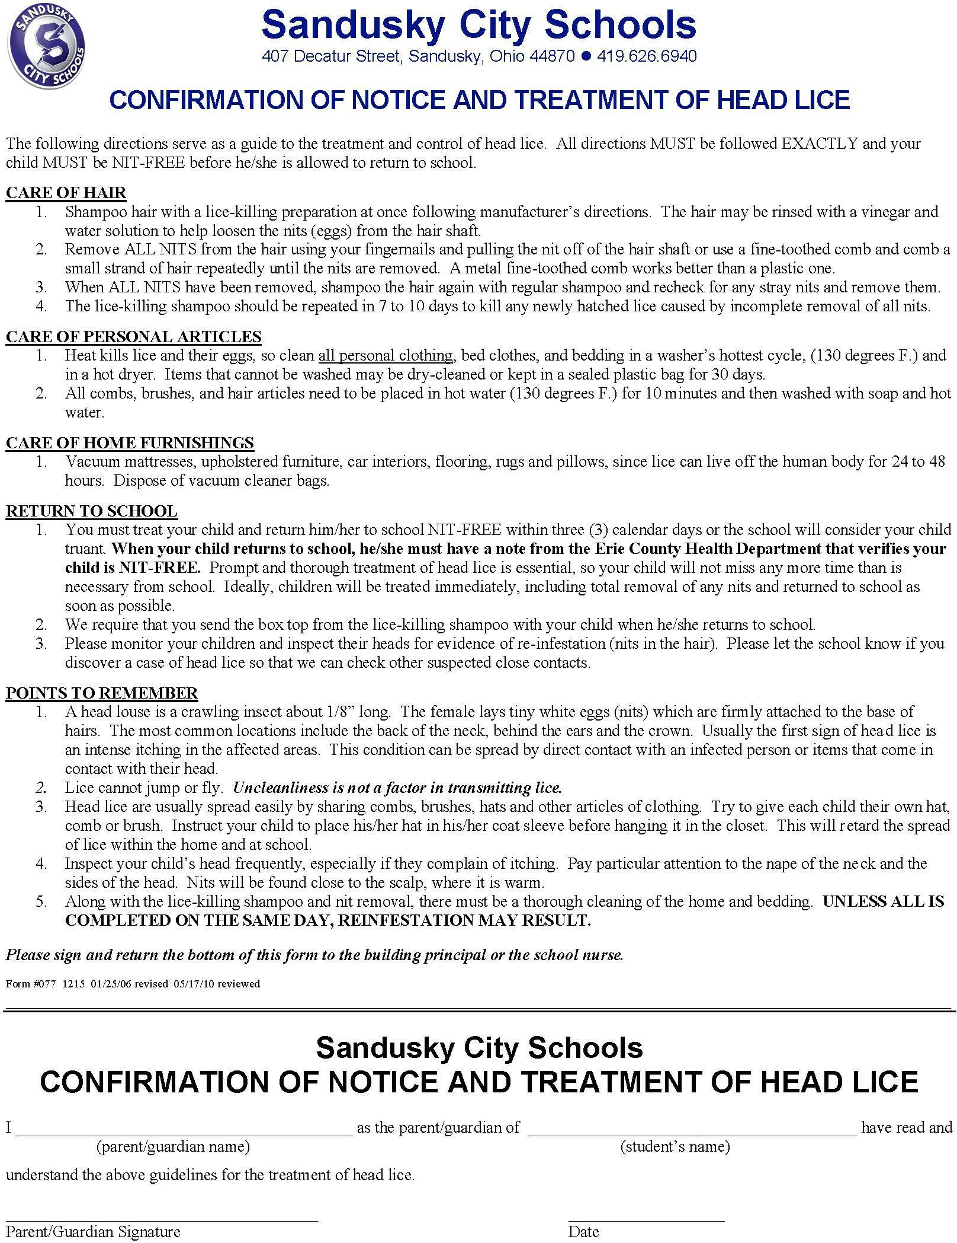

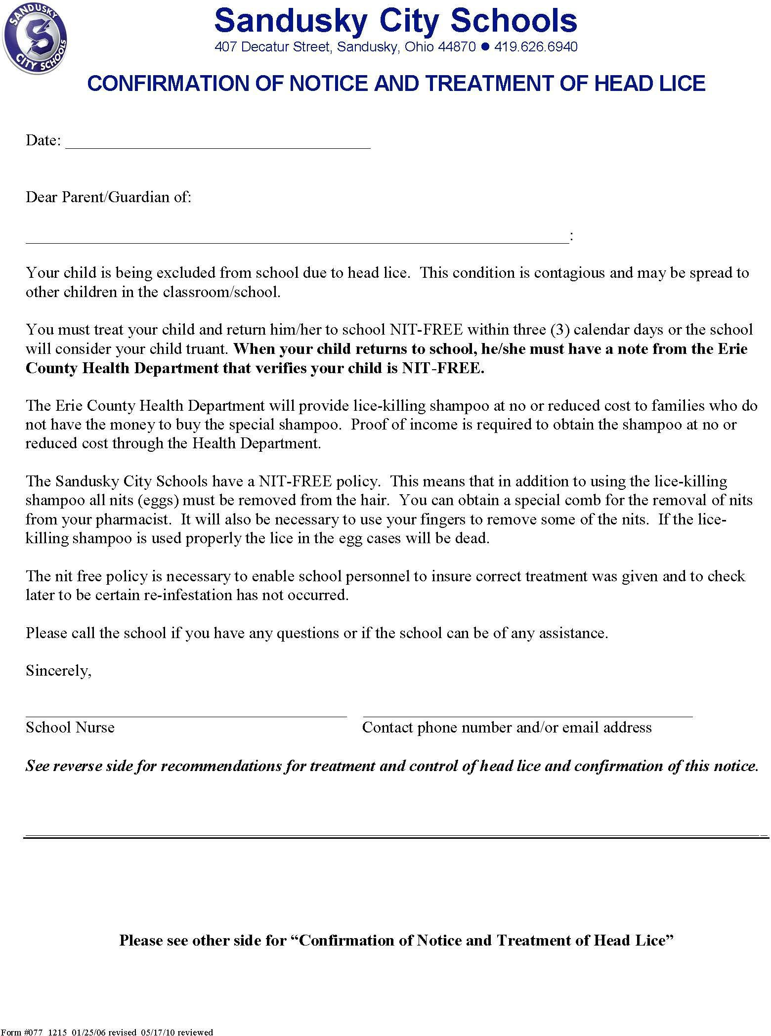


Sandusky City Schools
- -
•
.
407 Decatur St., Sandusky, OH 44870-2442♦ 419-626-6940
Change of Address and/or Contact Information
Parent/Legal Guardian (Guardian):
Please review and provide appropriate documents and complete information as indicated.
- What is your housing status? *The McKinney-Vento law may provide you with additional rights and
services that Sandusky City Schools may be able to furnish and assist you with.
_ Permanent Housing: Living in a fixed, regular and adequate housing situation
_ Doubled Up: Living with another family or person because of housing loss and economic hardship
_ Hotel/Motel: Living in a hotel/motel due to the lack of alternative adequate accommodations
_ Shelter: Emergency or transitional shelter
_ Other Temporary Living Situation: IE: Campground, car, park, public places, abandoned building, street
*The McKinney-Vento law says that homelessness indudes individuals who do not have a fixed, regular and adequate home because they have lost their own home**. Ask for a copy of .. A Parent's Guide to the Rights of Children and Youth Experiencing Homelessness, form 158A for additional and specific information. Contact SCS Student Services at 419-984-1048 for more information.
- Proof of Identity/Photo Identification: (Must be a current unexpired ID)
_Ohio Driver's License _State of Ohio ID _+Passport •A final resource when other ID is not available.
- Legal Guardianship: Are you the legal residential guardian: _No _ Yes; If applicable, please provide any original court stamped legal custody documents.
- Verification of Residency: (Please provide one verification of address)
_deed; _current mortgage statement; _rental/lease; _current property tax statement;
_purchase agreement w/possession date•; _building contract w/estimated completion date•
_current utility bill or receipt of utility installation issued within 30 days of enrollment;
_Landlord letter signed with phone number and notarized, valid for one year
  - students enrolling with residency documentation containing a future occupancy date may be enrolled for a period not to exceed ninety (90) calendar days prior to move-in.
  - No other forms of verification are accepted other than listed above; questions please call 419-626-6940
- What is the actual/effective date of your move?
[Please Print]

Old Address Zip Code + 4 Old Phone Number

New Address Zip Code + 4 New Phone Number

Cell Phone Number Child Name
Work Phone Number Email
Current School and Grade Level Special Education (Yes/ No)

••Affidavit of Current Residency (see back), I understand that I declare under penalty of perjury under the laws of Ohio that the information provided here is true and correct.

Parent/Legal Guardian Signature Date

STAFF MEMBER: Scan all documents listed above and this form, include all in one email to:
COA-Submission@scs-k12.net to complete process; for questions or information, call ext. O or 419-626-6940.
Form#093 Eflective3-10-23

++Affidavit of Current Residency
According to the Ohio Revised Code, a child must attend school in the district where the parent/legal guardian resides. School districts have the right to request verification of legal residency and the parent/legal guardian, not the school district, bears responsibility to verify and prove a challenged residency. It is also the responsibility of the parent/legal guardian to inform the school district of any address change within or outside of Sandusky City Schools, at any time after enrollment. By signing this affidavit, I am affirming that the address given on the student enrollment form(s), and this Affidavit is the legal residence of me, the parent/legal guardian, of the enrolled student(s) and the legal residence of said student(s). Further, I am aware of the policy of the Sandusky City Schools, which states that if a student is found to have residence in our district by using false or inaccurate information, the student will be dismissed/excluded from school until the issue is resolved by school administration.
If a determination is made that there was an attempt to defraud the school district, Sandusky City Schools will seek restitution. Sandusky City Schools may file charges vvith local authorities to prosecute and recover reimbursement for tuition and legal fees from the party or parties responsible.

I understand that those responsible will be held liable for all costs incurred while the student was enrolled in the Sandusky City Schools. I understand that I declare under penalty of perjury under the laws of Ohio that the information provided here is true and correct.


Sandusky City Schools
Sandusky, Ohio 44870
419-626-6940

Family Educational Rights and Privacy Act (FERPA)

Certain directory information may be released to media, colleges, civic or school-related organizations, and state or governmental agencies.

The Family Educational Rights and Privacy Act (FERPA) (20 USC § 1232g; 34 CFR Part 99) is a Federal law that protects the privacy of student education records. The law applies to all schools that receive funds under an applicable program of the U. S Department of Education. FERPA gives parents certain rights with respect to their children's education records. These rights transfer to the student when he or she reaches the age of 18 or attends a school beyond the high school level. Students to whom the rights have transferred are "eligible students."
- Parents or eligible students have the right to inspect and review the student's education records maintained by the school. Schools are not required to provide copies of records unless, for reasons such as great distance, it is impossible for parents or eligible students to review the records. Schools may charge a fee for copies.
- Parents or eligible students have the right to request that a school correct records which they believe to be inaccurate or misleading. If the school decides not to amend the record, the parent or eligible student then has the right to a formal hearing. After the hearing, if the school still decides not to amend the record, the parent or eligible student has the right to place a statement with the record setting forth his or her view about the contested information.
- Generally, schools must have written permission from the parent or eligible student in order to release any information from a student's education record. However, FERPA allows schools to disclose those records, without consent, to the following parties or under the following conditions (34 CFR § 99.31)
  - School officials with legitimate educational interest;
  - other schools to which a student is transferring;
  - Specified officials for audit or evaluation purposes;
  - Appropriate parties in connection with financial aid to a student;
  - Organizations conducting certain studies for or on behalf of the school;
  - Accrediting organizations;
  - To comply with a judicial order or lawfully issued subpoena;
  - Appropriate officials in cases of health and safety emergencies; and
  - State and local authorities, within a juvenile justice system, pursuant to specific State law.

Schools may disclose, without consent, "directory" information such as a student's name, address, telephone number, date and place of birth, honors and awards, and dates of attendance. However, schools must tell parents and eligible students about directory information and allow parents and eligible students a reasonable amount of time to request that the school not disclose directory information about them. Schools must notify parents and eligible students annually of their rights under FER PA The actual means of notification (special letter, inclusion in a PT A bulletin, student handbook, or newspaper article) is left to the discretion of each school.

Parent/Legal Guardian or Eligible Student if you do not want your child's (your) directory information shared, please complete the following and return it to the school your child attends.

Name of Student:

School: Date: _ Ichoose not to have my child's (my) directory information shared.
Parent/Legal Guardian or Eligible Student Signature:

Form 020 1200 Revised 03-08-2016

This page intentionally left blank.


Sandusky
Early Learning Academy
2314 Hancock St., Sandusky, OH 44870-4944  419-984-1210  www.scs-k12.net

SANDUSKY CITY SCHOOLS PRESCHOOL ANNUAL TUITION RATES SY 2024-2025

Poverty Level | At or Below 100% of  the Federal Poverty Level | 101% - 200% of the Federal Poverty Level | Above 200% of the Federal Poverty Level
Children with an Individualized Education Program | $0 | $0 | $0
Half Day Programming  (Non ECE) | $0 | $0 | $0
ECE Student Tuition | $0 | $0 | $0

*Federal Poverty Guidelines for 2024

Size of Family Unit | 100%  Poverty  Level | 125%  Poverty  Level | 150%  Poverty  Level | 175%  Poverty  Level | 185%  Poverty  Level | 200%  Poverty  Level
1 | $15,060 | $18,825 | $22,590 | $26,355 | $27,861 | $30,120
2 | $20,440 | $25,550 | $30,660 | $35,770 | $37,814 | $40,880
3 | $25,820 | $32,275 | $38,730 | $45,185 | $47,767 | $51,640
4 | $31,200 | $39,000 | $46,800 | $54,600 | $57,720 | $62,400
5 | $36,580 | $45,725 | $54,870 | $64,015 | $67,673 | $73,160
6 | $41,960 | $52,450 | $62,940 | $73,430 | $77,626 | $83,920
7 | $47,340 | $59,175 | $71,010 | $82,845 | $87,579 | $94,680
8 | $52,720 | $65,900 | $79,080 | $92,260 | $97,532 | $105,440
Family units with more  than 8 members | Add  $5,380 for each  additional | Add  $6,725 for each  additional | Add  $8,070 for each  additional | Add  $9,415 for each  additional | Add  $9,953 for each  additional | Add  $10,760  foreach  additional

Source: https://aspe.hhs.gov/poverty-guidelines

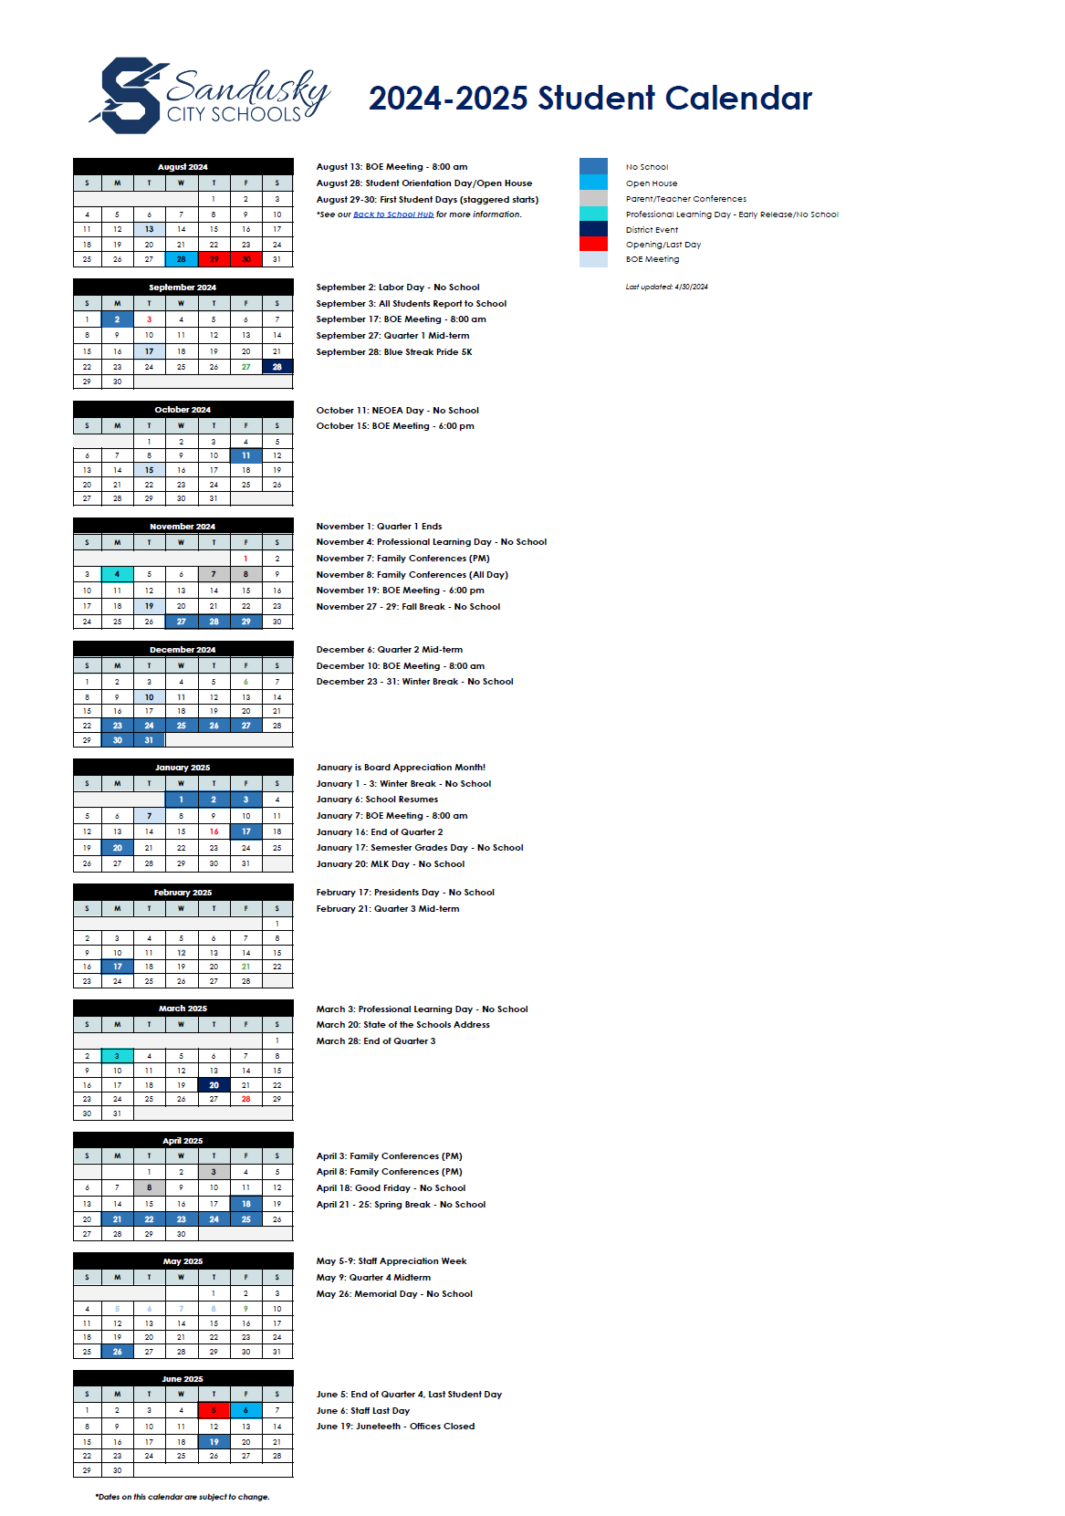



For calendar information, forms, and building events, and much more… please visit our website at www.scs-k12.net !

NOTICE TO: Parent/Guardian
Please complete the section below and return to your child’s school as soon as possible.


Parent/Guardian Acknowledgement Form
We have read and understand the guidelines, rules, and regulations presented in the Sandusky City Schools Student Handbook and Conduct and Disciplinary Information.

[Please Print]
Parent/Guardian Name Parent/Guardian Name

Signatures 
Parent/Guardian Signature Parent/Guardian Signature

[Please Print]
Student Name (Please Print) Date

This page intentionally left blank.


Download our app and enable notifications for information during the school year.




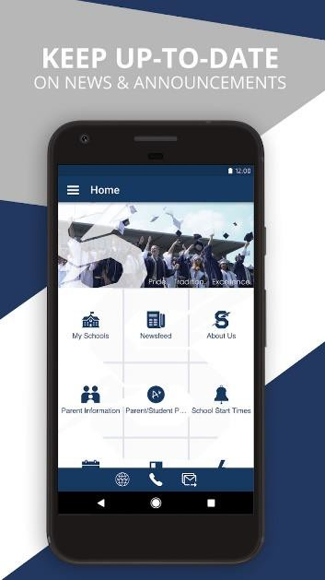
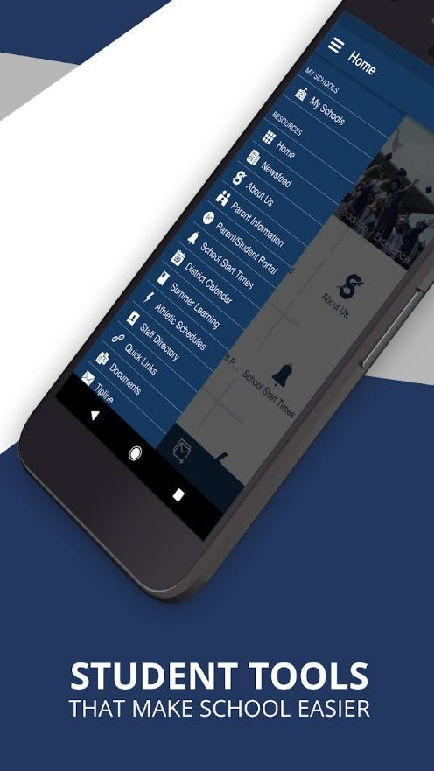


play.google.com/store

apple.com/app-store/



Visit our website scs-k12.net and find us on

